Số câu làm đc trong bài kiểm tra 12/12

Bài thực hành số 1

Câu 1:

Code;

/* nhap vao gia tri x bat ky. roi tinh gia tri theo bieu thuc sau y=X^3+sin2.5-1.8 */

#include<stdio.h>

#include<conio.h>

#include<math.h>

int main(){

puts("Nguyen_Van_Nga_udpm1-k12_CD200163");

float x;

printf("Nhap x = ");

scanf("%f",&x);

printf("\n Y = x^3 + sin2.5x -1..68= %6.2f",(x*x*x)+sin(2.5)*x -1.68);

getch();

}

Ảnh;

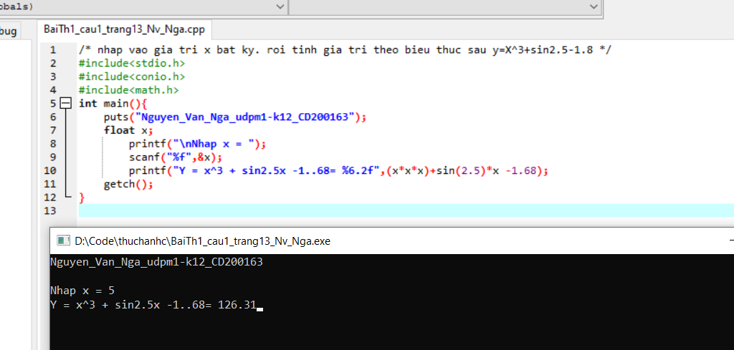

Câu 3;

Code;

/*viet chuong trinh nhap so nguyen co 3 chu so,

hien chu so hang tram, hang chuc, hang don vi */

#include<stdio.h>

#include<conio.h>

int main(){

puts("Nguyen_Van_Nga_udpm1-k12_CD200163");

int x;

printf("\n Nhap so nguyen gom 3 chu so =");

scanf("%d",&x);

printf("\n Chu so hang tram la: %d", x/100);

printf("\n Chu so hang chuc la: %d", x%100/10);

printf("\n Chu so hang don vi la: %d", x%10);

getch();

}

Ảnh;

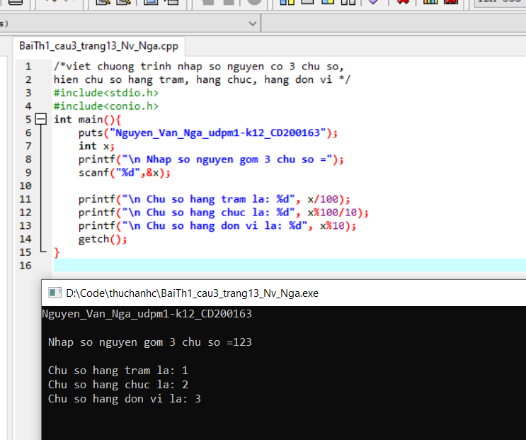

Câu 4;

Code

/*cho 3 diem chuyen can, giua ky, cuoi ky

tinh diem mon hoc theo 3 diem tren */

#include<stdio.h>

#include<conio.h>

float TB(float Chuyencan, float Giuaky, float Cuoiky){

float TB = Chuyencan*0.1 + Giuaky*0.3 + Cuoiky*0.6;

return TB;

}

int main(){

puts("Nguyen_Van_Nga_udpm1-k12_CD200163");

float Chuyencan,Giuaky,Cuoiky;

printf("\nChuyen can = ");

scanf("%f", &Chuyencan);

printf("\nGiua ky = ");

scanf("%f", &Giuaky);

printf("\nCuoi Ky = ");

scanf("%f", &Cuoiky);

printf("\nDiem TB mon hoc la : %.1f", TB(Chuyencan, Giuaky, Cuoiky));

return 0;

}

Ảnh;

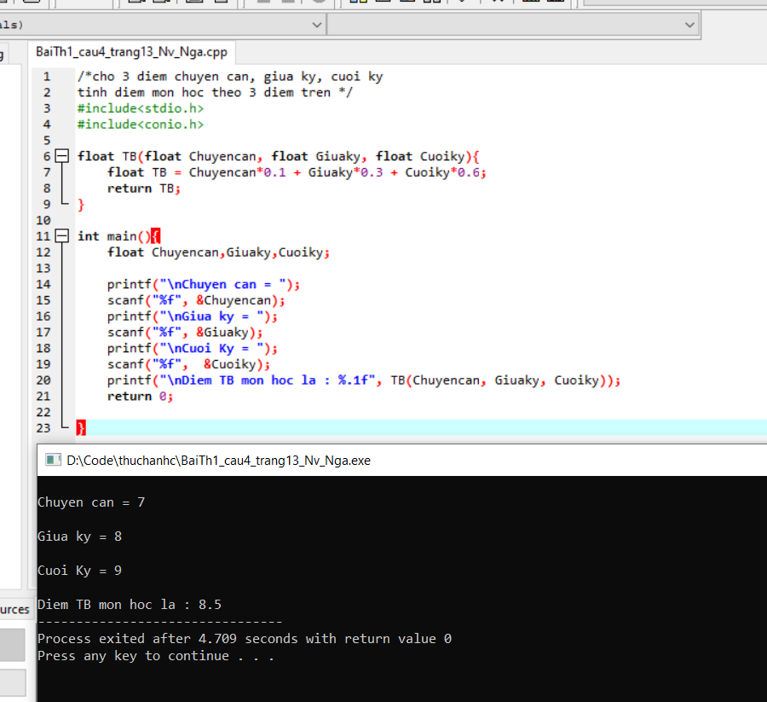

Câu 6;

Code

/*nhap ban kinh cua duong tron r. roi tinh chu vi va dien tich. */

#include<stdio.h>

#include<conio.h>

#include<math.h>

float chuvi(const float pi, float r){

float chuvi = r * 2 * pi;

return chuvi;

}

float dientich (const float pi, float r){

float dientich = pi * pow(r, 2);

return dientich;

}

int main (){

puts("Nguyen_Van_Nga_udpm1-k12_CD200163");

float r;

const float pi = 3.1415;

printf("\n nhap r = ");

scanf("%f", &r);

printf("\n chu vi hinh tron = %2.2f cm", chuvi(pi, r));

printf("\n dien tich duong tron = %3.3f cm2", dientich(pi, r));

getch();

}

Ảnh

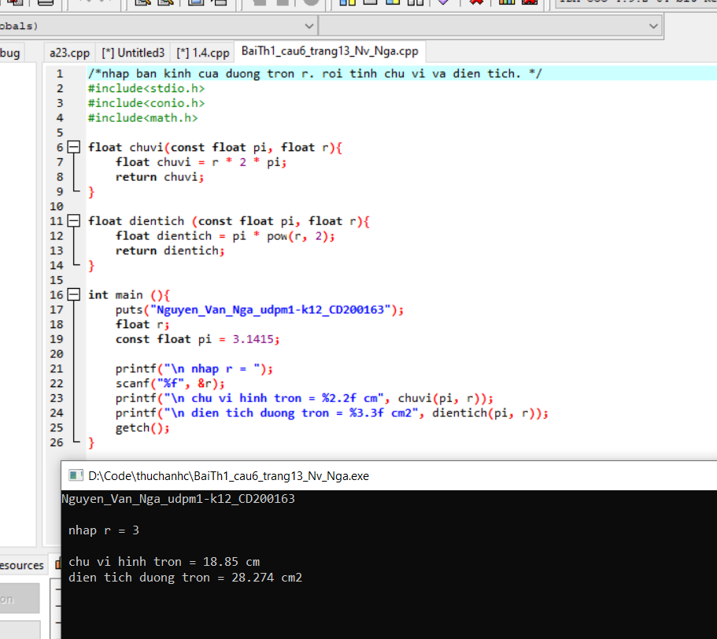

Bài thực hành số 2

Phần A;

Câu 2.1;

Code

/*Nhap vao mot so co 3 chu so trong khoang 111-999. kiem tra xem do co thoa man tong lap phuong cua chinh no ko*/

#include<stdio.h>

#include<math.h>

int main(){

puts("Nguyen_Van_Nga_udpm1-k12_CD200163");

int x;

printf("nhap 1 so tu 100 den 999 : ");

scanf("%d", &x);

int a=x/100, b=(x%100)/10, c=x%10;

if(pow(a,3)+ pow(b,3)+ pow(c,3)==x)

printf("\n %d la so tong lap phuong", x);

else

printf("\n %d ko phai la so tong lap phuong", x);

return 0;

}

Ảnh

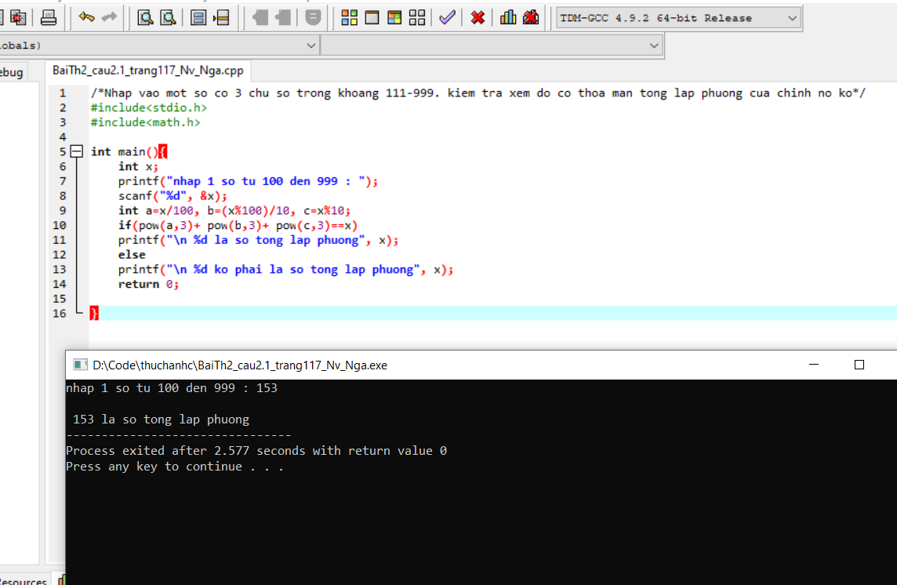

Câu 2.2

Code

/*nhap vao mot ky tu k va kiem tra do co phai la chu hoa hay khong*/

#include<stdio.h>

#include<conio.h>

int main() {

puts("Nguyen_Van_Nga_udpm1-k12_CD200163");

char k;

printf("nhap vao mot ky tu :"); fflush(stdin);

scanf("%c", &k);

if(k<=90&&k>=66)

printf("%c la chu cai hoa ", k);

else

printf("%c ko phai chu cai hoa",k);

getch ();

}

Ảnh

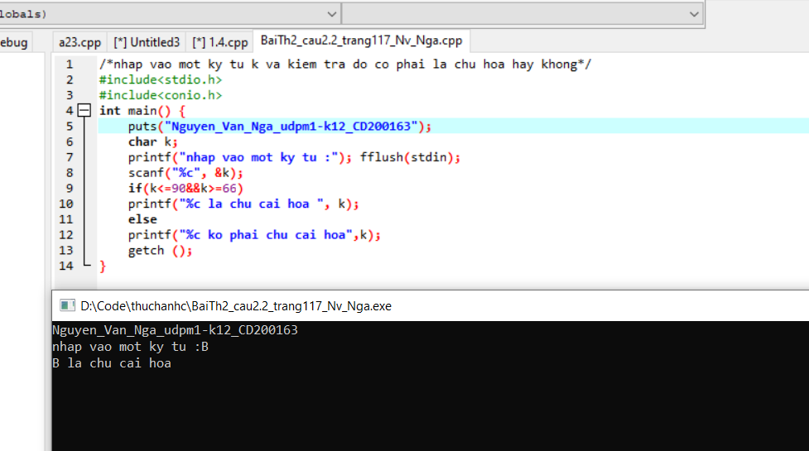

Câu 2.3

Code

/*nhap 3 so x,y,z xem do co phai day cap so cong hay ko*/

#include<stdio.h>

#include<conio.h>

int main(){

puts("Nguyen_Van_Nga_udpm1-k12_CD200163\n");

int x, y, z;

printf("nhap 3 so x y z =");

scanf("%d \t %d \t %d", &x, &y, &z);

if((x+z)/2==y)

printf("ba so da cho tao thanh cap so cong");

else

printf("ba so da cho khong thoa man tinh chat");

getch();

}

Ảnh

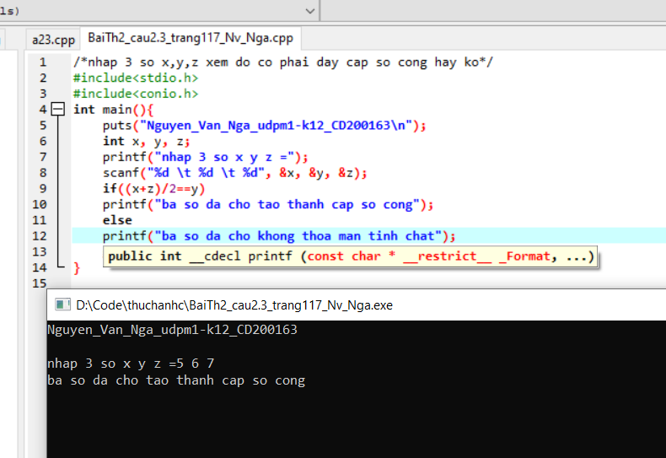

Câu 4

Code

/*nhap do 3 so a,b,c xem do co phai do dai 3 canh cua 1 tam giac ko. neu dung thi tinh dien tich tam giac do*/

#include<stdio.h>

#include<conio.h>

#include<math.h>

float s(float a, float b, float c)

{

float p=(a+b+c)/2;

float s=sqrt(p*(p-a)*(p-b)*(p-c));

return s;

}

int main(){

puts("Nguyen_Van_Nga_udpm1-k12_CD200163\n");

float a, b, c, p;

printf(" nhap do dai 3 canh cua tam giac = ");

scanf("\n%f %f %f", &a, &b, &c);

if(a>0&&b>0&&c>0&&a+b>c&&b+c>a&&c+a>b){

printf("\ndien tich tam giac = %.2f", s(a, b, c));

}

else

printf("\nabc khoong phai do dai 3 canh cua tam giac");

getch();

}

Ảnh

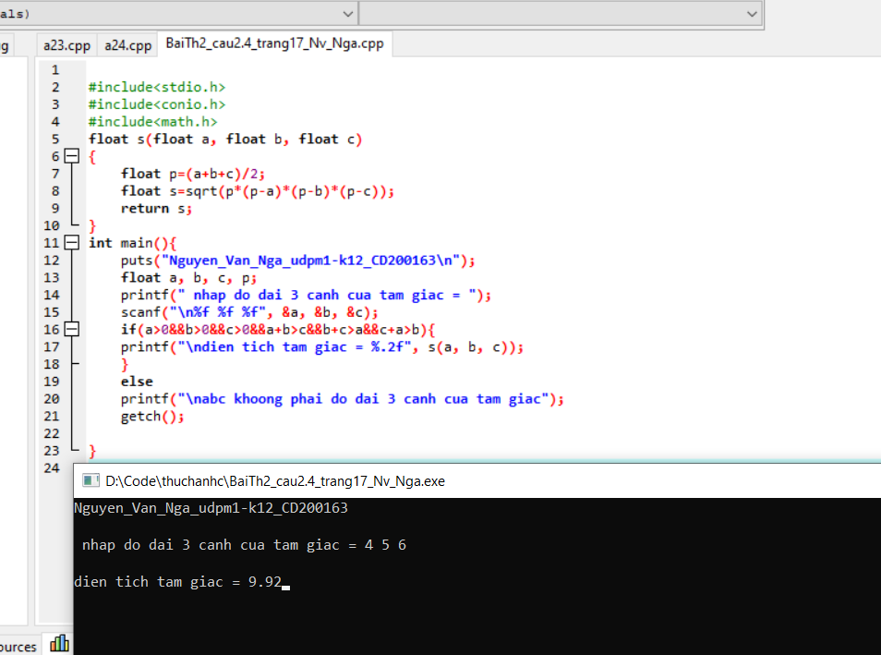

Câu 2.5

Code

/*viet ct giai va bien luan cua pt bac nhat*/

#include<stdio.h>

#include<conio.h>

#include<math.h>

int main(){

puts("Nguyen_Van_Nga_udpm1-k12_CD200163\n");

float a, b, x;

printf("nhap so a =");

scanf("%f", &a);

printf("nhap so b =");

scanf("%f", &b);

if(a==0){

if(b==0)

printf("\n pt co vo so nghiem");

else

printf("\n pt vo nghiem");

}

else

printf("\n pt co nghiem duy nhat x = %.2f", -b/a);

getch();

}

Ảnh

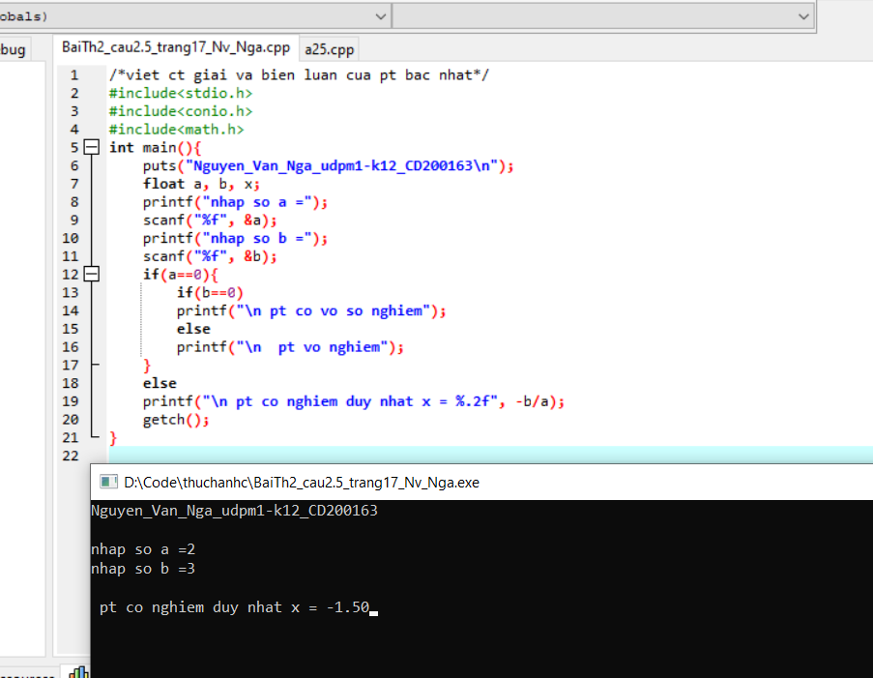

Câu 2.6

Code

/*viet ct va bien luan giai pt bac 2*/

#include<stdio.h>

#include<conio.h>

#include<math.h>

float delta(float a, float b, float c){

float delta= b*b-4*(a*c);

return delta;

}

int ptbac2(float a, float b, float c, float *x1, float *x2){

if(a==0){

if(b==0){

if(c==0)

return 1;

else

return -1;

}

else{

*x1 = *x2 = -c/b;

return 0;

}

}

else

{

float d = delta(a,b,c);

printf("\n delta = %f", d);

if(d>0){

*x1 = (-b+sqrt(d))/(2*a);

*x2 = (-b-sqrt(d))/(2*a);

}

//printf("\n x1 =%f \t x2 = %f",(-b+sqrt(d))/(2*a), (-b-sqrt(d))/(2*a) );

else{

if(d==0)

//printf("\n x = %f", -b/(2*a));

{

*x1 = *x2 = -b/(2*a);

return 0;

}

else

return -1;

}

}

}

int main () {

puts("Nguyen_Van_Nga_udpm1-k12_CD200163\n");

float a, b, c;

float x1, x2;

printf(" mhap a = ");

scanf("%f", &a);

printf(" mhap b = ");

scanf("%f", &b);

printf(" mhap c = ");

scanf("%f", &c);

int check = ptbac2(a,b,c,&x1,&x2);

if(check == -1)

puts("\nPT vo nghiem");

else if(check == 1)

puts("\nPT vo so nghiem");

else

printf("\n x1= %f\nx2 = %f",x1,x2);

getch();

}

Ảnh

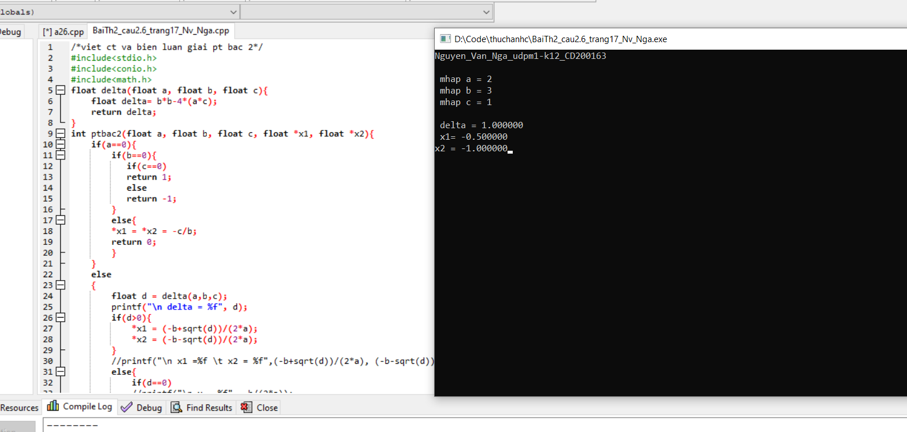

Câu 3

Code

/*nhap diem trung binh va xep loai hs */

#include<stdio.h>

#include<conio.h>

#include<math.h>

int main(){

puts("Nguyen_Van_Nga_udpm1-k12_CD200163\n");

float diemtb;

printf("nhap so diem TB =");

scanf("%f", &diemtb);

if(diemtb>=8.0)

printf("\nloai gioi");

else if(diemtb>=6.5&&diemtb<=7.9)

printf("\nloai kha");

else if(diemtb>=5.0&&diemtb<=6.4)

printf("\nloai trung binh");

else

printf("\nloai yeu");

getch();

}

Ảnh

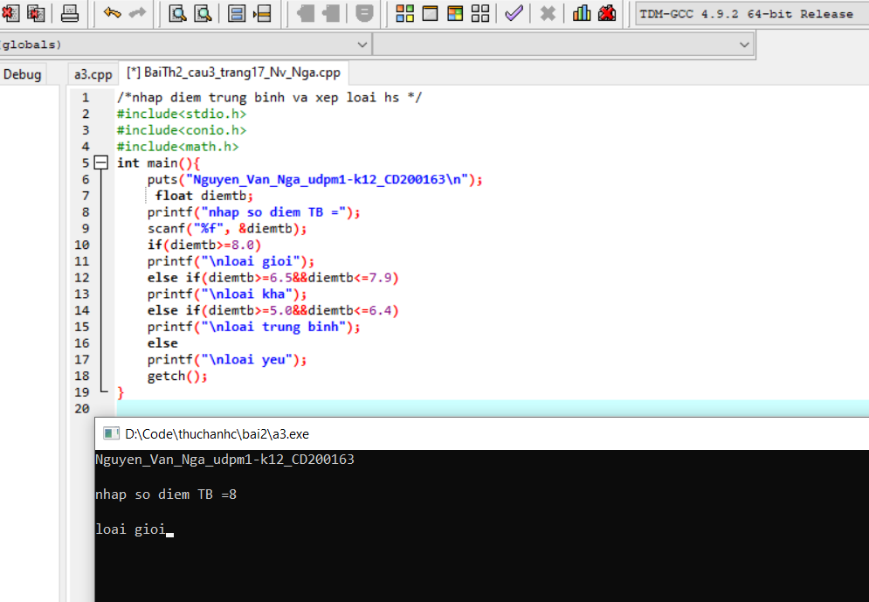

Phần B;

Câu 2

Code

/*Go mot so tu mot den 9 roi doc chu so do*/

#include<stdio.h>

#include<conio.h>

int main() {

puts("Nguyen_Van_Nga_udpm1-k12_CD200163\n");

int x;

printf("nhap 1 so tu 0-9 :");

scanf("%d", &x);

switch(x)

{

case 0: printf("\n Khong"); break;

case 1: printf("\n Mot"); break;

case 2: printf("\n Hai "); break;

case 3: printf("\n Ba "); break;

case 4: printf("\n Bon"); break;

case 5: printf("\n Nam"); break;

case 6: printf("\n Sau"); break;

case 7: printf("\n Bay"); break;

case 8: printf("\n Tam"); break;

case 9: printf("\n Chin"); break;

default: printf("\n Nhap khong dung");

}

getch();

}

Ảnh

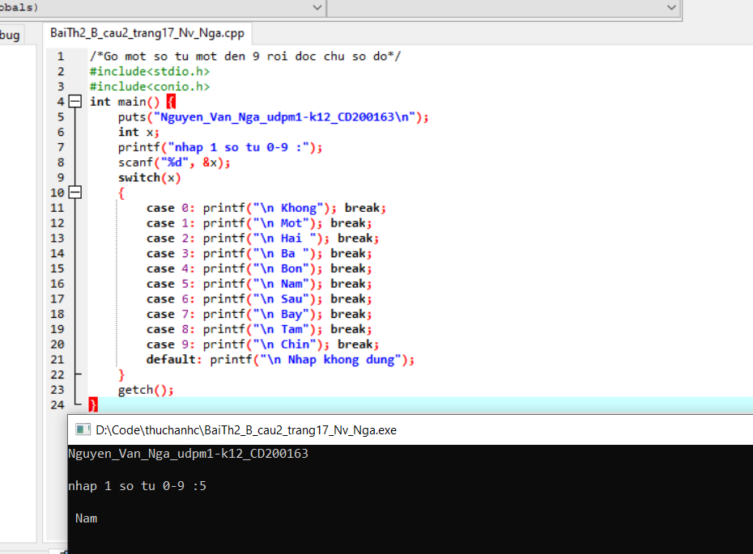

Câu 3

Code

#include<stdio.h>

#include<conio.h>

int main() {

puts("Nguyen_Van_Nga_udpm1-k12_CD200163\n");

int x;

printf("nhap 1 so la thang trong nam 1-12 : \t");

scanf("%d", &x);

switch(x)

{

case 1:

case 2:

case 3: printf(" mua xuan"); break;

case 4:

case 5:

case 6: printf(" mua ha"); break;

case 7:

case 8:

case 9: printf(" mua thu"); break;

case 10:

case 11:

case 12: printf(" mua dong"); break;

}

getch();

}

Ảnh

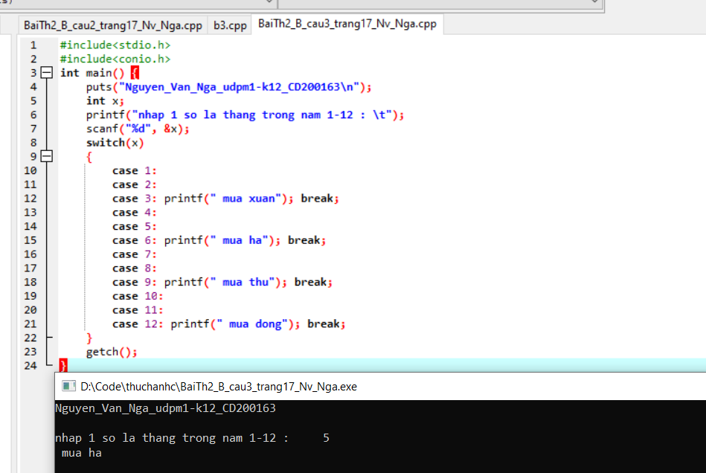

Phần C;

Câu 3

Code

#include<stdio.h>

#include<conio.h>

int main (){

puts("Nguyen_Van_Nga_udpm1-k12_CD200163\n");

int a;

printf("nhap diem thi : ");

scanf("%d", &a);

while (a<0 || a>10)

{

printf("\n Sai ! nhap lai :");

scanf("%d", &a);

}

printf("\n so diem thi la : %d", a);

getch ();

}

Ảnh

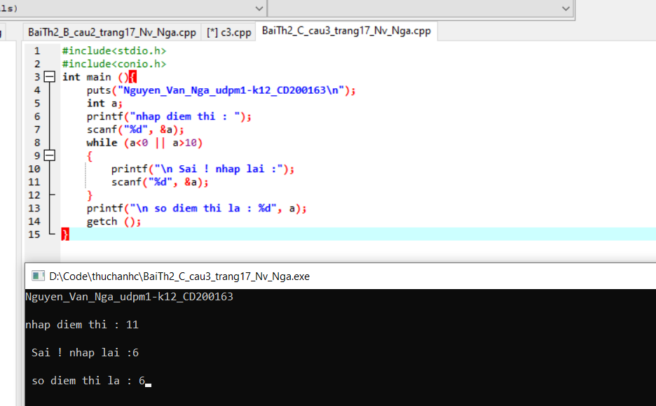

Câu 5

Code

//tinh tong cac so chan tu 1 den 100

#include<stdio.h>

#include<conio.h>

int main(){

puts("Nguyen_Van_Nga_udpm1-k12_CD200163\n");

int s=0;

for(int i=2; i<=100; i+=2){

s+=i;

printf("%4d",i);

if(i%20 ==0)

printf("\n");

}

printf("Tong cac so chan tu 1 - 100 = %d", s);

getch ();

}

Ảnh

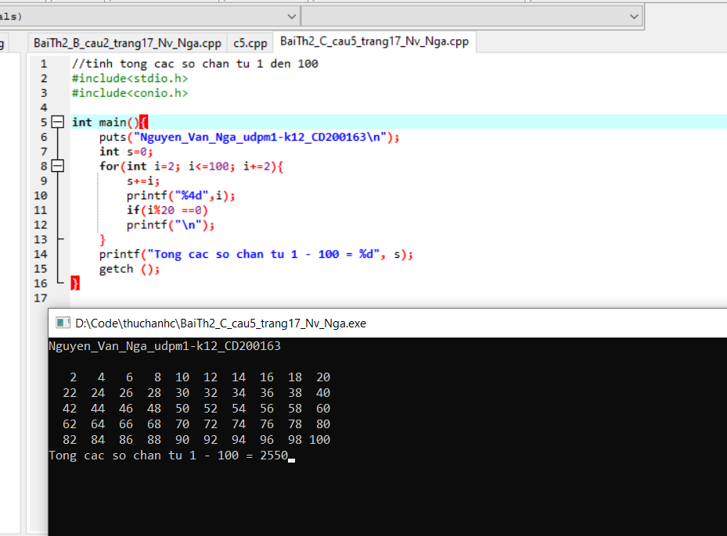

Câu 6

Code

//tinh tong so co 3 chu so tu 100 den 999 chia het cho 5

#include<stdio.h>

#include<conio.h>

int main(){

puts("Nguyen_Van_Nga_udpm1-k12_CD200163\n");

int s=0,i=100;

do{

s+=i;

i+=5;

}

while(i<=999);

printf("Tong cac so co 3 chu so chia het cho 5 la: %d",s);

getch();

}

Ảnh

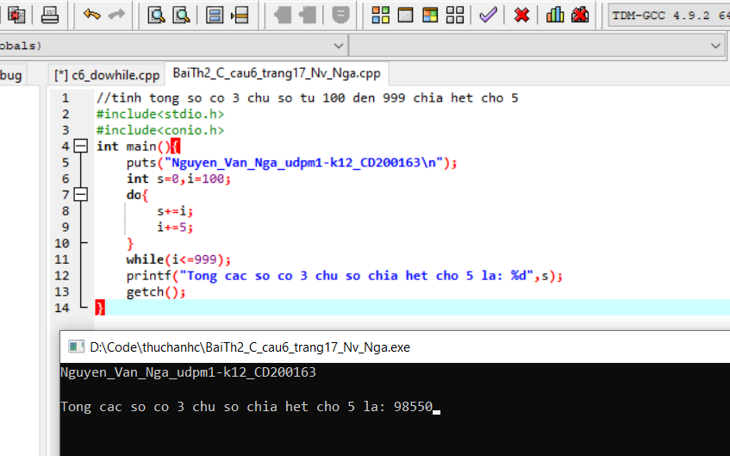

Câu 7

Code

// nhap 1 so nguyen roi tinh giai thua so do

#include<stdio.h>

#include<conio.h>

#include<math.h>

int main(){

puts("Nguyen_Van_Nga_udpm1-k12_CD200163\n");

int n, s=1;

printf("nhap n =");

scanf("%d", &n);

for(int i=2;i<=n;i++)

s*=i;

printf("%d! = %d",n,s);

getch();

}

Ảnh

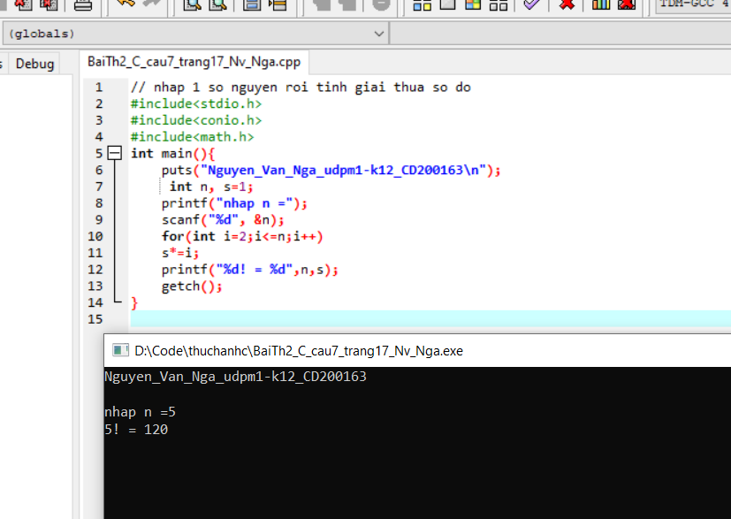

Bài thực hành số 3

Phần A; Xây dựng và sử dụng hàm

Câu 1

Code

#include<stdio.h>

#include<conio.h>

#include<math.h>

//khai bao ham tinh tong so nguyen

int tong(int x, int y){

int z;

z= x + y;

return z;

}

int main(){

puts("Nguyen_Van_Nga_udpm1-k12_CD200163\n");

int x, y;

printf("nhap x =");

scanf("%d",&x);

printf("nhap y =");

scanf("%d",&y);

printf("\n%d + %d = %d",x,y,tong(x,y));

getch();

}

Ảnh

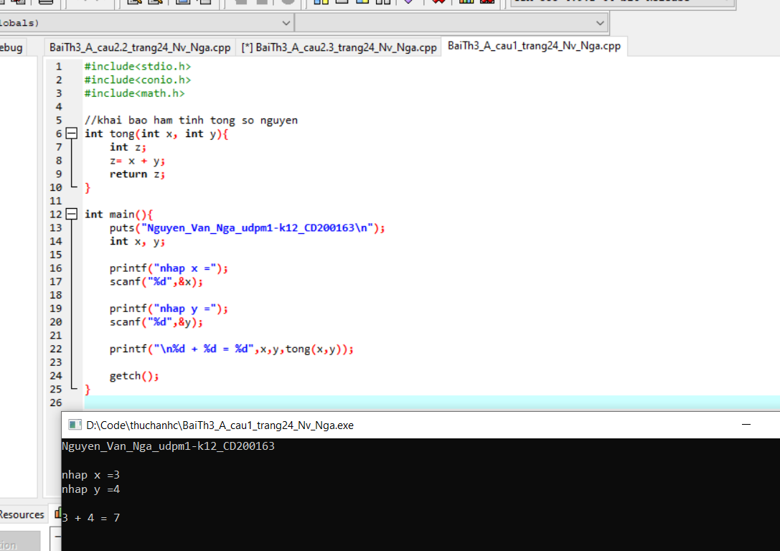

Câu 2.1

Code

Ảnh

Câu 2.2

Code

//viet ham tinh dien tich cua 1 tam giac, khi biet do dai cua 1 tam giac do

#include<stdio.h>

#include<conio.h>

#include<math.h>

// ham tinh chu vi cua tam giac

float p(float a, float b, float c){

float p;

p = a + b + c;

return p;

}

//ham tinh dien tich cua tam giac

float s(float a, float b, float c){

float s, x;

x=p(a,b,c);

s =sqrt(x*(x-a)*(x-b)*(x-c));

return s;

}

int main(){

puts("Nguyen_Van_Nga_udpm1-k12_CD200163\n");

float a, b, c;

printf("Nhap a =");

scanf("%f",&a);

printf("Nhap b =");

scanf("%f",&b);

printf("Nhap c =");

scanf("%f",&c);

if(a > 0 && b > 0 && c > 0 && a + b > c && b + c > a && c + a > b)

{

p(a, b, c);

printf("Dien tich cua tam giac = %6.2f cm2", s(a, b, c));

}

else

printf("Do khong phai la do dai 3 canh cau tam giac !");

getch();

}

Ảnh

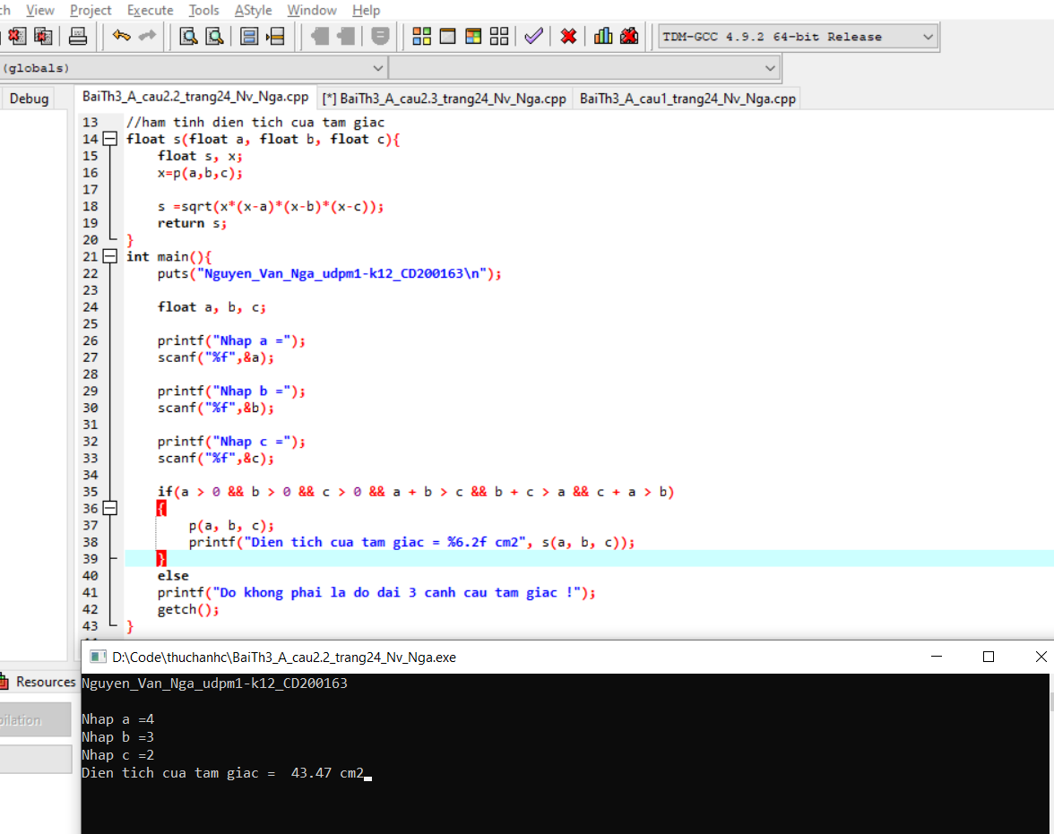

Câu 2.3

Code

// viet ham tinh chu vi cua tam giac

#include<stdio.h>

#include<conio.h>

#include<math.h>

// ham tinh chu vi cua tam giac

float p(float a, float b, float c){

float p;

p = a + b + c;

return p;

}

int main(){

puts("Nguyen_Van_Nga_udpm1-k12_CD200163\n");

float a, b, c;

printf("Nhap a =");

scanf("%f",&a);

printf("Nhap b =");

scanf("%f",&b);

printf("Nhap c =");

scanf("%f",&c);

if(a > 0 && b > 0 && c > 0 && a + b > c && b + c > a && c + a > b)

printf("chu vi cua tam giac la: %.2f cm",p(a,b,c));

else

printf("Do khong phai la do dai 3 canh cau tam giac !");

getch();

}

Ảnh

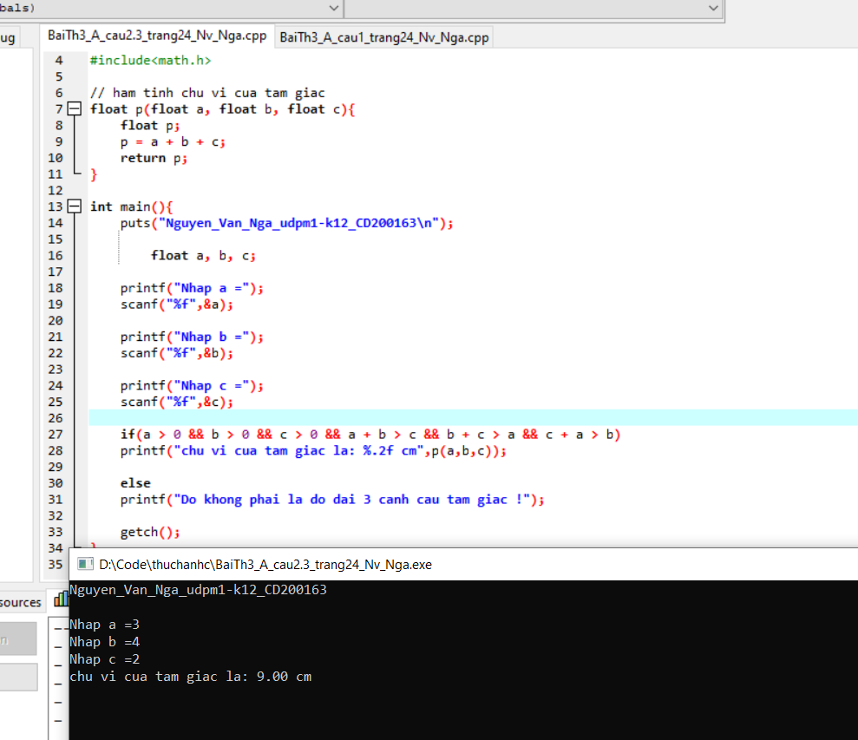

Câu 2.4

Code

// viet ham tinh so lon nhat cua 3 so

#include<stdio.h>

#include<conio.h>

#include<math.h>

// ham tim so lon nhat

float max(float a, float b, float c){

float max;

max = a;

if(b > max)

max = b;

if(c > max)

max = c;

return max;

}

int main(){

puts("Nguyen_Van_Nga_udpm1-k12_CD200163\n");

float a, b, c;

printf("Nhap a =");

scanf("%f",&a);

printf("Nhap b =");

scanf("%f",&b);

printf("Nhap c =");

scanf("%f",&c);

printf("so lon nhat la: %.2f", max(a,b,c));

getch();

}

Ảnh

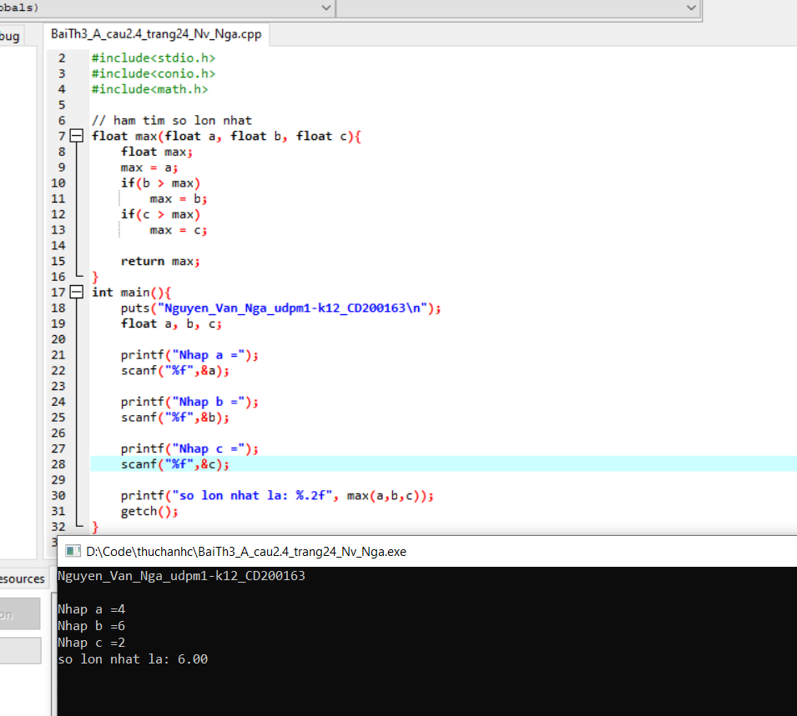

Câu 3

Code

// viet ham tinh trung binh cong cua 2 so

#include<stdio.h>

#include<conio.h>

#include<math.h>

// ham tinh trung binh cua hai so

float TB(int a, int b){

float TB;

TB = (float)(a+b) / 2;

return TB;

}

int main(){

puts("Nguyen_Van_Nga_udpm1-k12_CD200163\n");

int a, b;

printf("Nhap a =");

scanf("%d",&a);

printf("Nhap b =");

scanf("%d",&b);

printf("trung binh cua hai so = %.1f",TB(a,b));

getch();

}

Ảnh

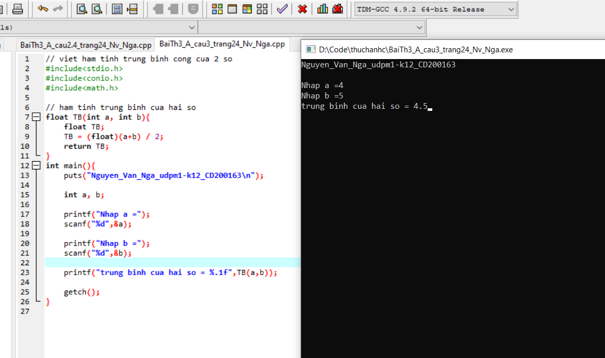

Phần B; dữ liệu kiểu mảng

Câu 1

Code

// Nhap so nguyen tu ban phim thoa man dk 3<= n <= 30

// nhap so nguyen n luu vao mang A

//hien lai mang vua nhap 6 phan tu tren 1 hang, moi phan tu chiem 4 vi tri

#include<stdio.h>

#include<conio.h>

#include<math.h>

int main(){

puts("Nguyen_Van_Nga_udpm1-k12_CD200163\n");

int n, A[30], dem =0;

printf(" nhap n =");

do{

scanf("%d",&n);

if(n <3 || n > 30)

printf("Nhap lai! chu y dieu kien cua n =");

}

while(n <3 || n > 30);

//nhap mang

for(int i = 0;i<=n;i++)

{

printf("\n A[%d] =",i);

scanf(" %d", &A[i]);

}

// hien mang

printf("\n mang du lieu vua nhap la:\n");

for(int i=0;i<=n;i++){

if(i % 6 ==0)

printf("\n%4d",A[i]);

else

printf(" %4d",A[i]);

}

// tinh gia tri trung binh

float TB, sum = 0;

for(int i=0;i<=n;i++){

sum = +A[i];

}

TB = sum/2;

printf("\nGIA TRI TRUNG BINH CAU MANG A LA: %.2f",TB);

// dem so pt trong A lon hon gtri TB

printf("\n");

printf("\ncac pt cua A lon hon TB la:");

for(int i=0;i<=n;i++){

if(A[i]>TB)

printf("%d\t",A[i]);

}

getch();

}

Ảnh

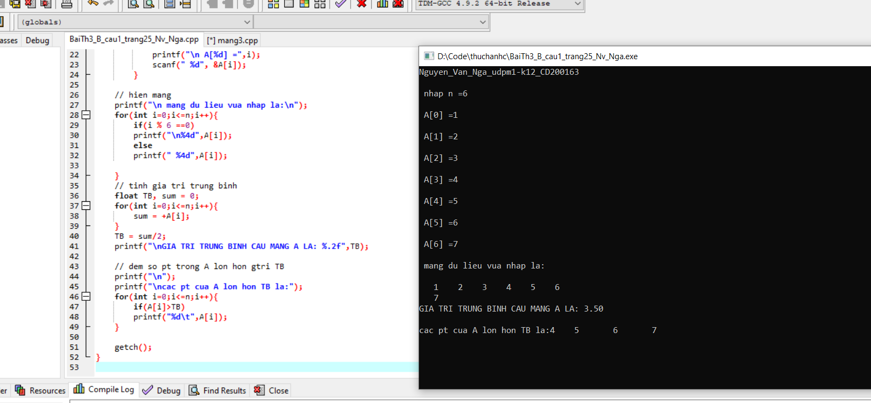

Câu 2.1

Code

#include<stdio.h>

#include<conio.h>

#include<math.h>

int main(){

puts("Nguyen_Van_Nga_udpm1-k12_CD200163\n");

int n, A[38];

printf("Nhap n=");

do{

scanf("%d",&n);

if(n<4 || n>38)

printf("Nhap lai n =");

}

while(n<4 || n>38);

// nhap mang

for(int i=0;i<n;i++){

printf("A[%d] =",i);

scanf("\n%d",&A[i]);

}

//so pt chia het cho 5

printf("\nso pt chia het cho 5 la:\t");

for(int i=0;i<n;i++){

if(A[i]%5==0){

printf("%d\t",A[i]);

}

}

getch();

}

Ảnh

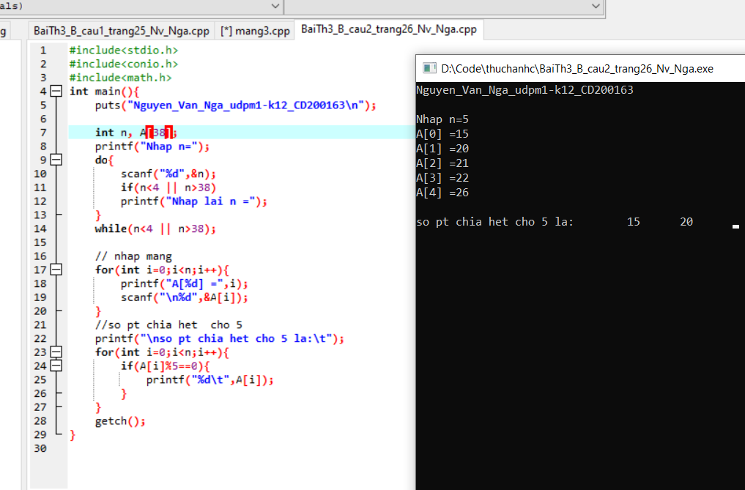

Câu 2.2

Code

/* nhap 1 so nguyen n thoa man dk 4<= n <= 26

nhsp n do thuc luu vso msng x

tinh gtri tb cua mang x luu vao bien TB

dem so pt trong x co gtri > TB

*/

#include<stdio.h>

#include<conio.h>

#include<math.h>

int main(){

puts("Nguyen_Van_Nga_udpm1-k12_CD200163\n");

int n;

float X[26],TB;

printf("Nhap n =");

do{

scanf("%d",&n);

if(n<4 || n>26)

printf("Nhap lai n =");

}

while(n<4 || n>26);

// Nhap mang

for(int i=0;i<n;i++){

printf("\nX[%d] =",i);

scanf("%f", &X[i]);

}

float sum=0;

//tinh gtri trung binh cua mang

for(int i=0;i<n;i++){

sum+=X[i];

}

TB= sum/n;

printf("GIA TRI TRUNG BINH CUA MANG LA: %.2f",TB);

printf("\ncac pt cua mang X lon hon TB la:");

for(int i = 0; i < n; i++){

if(X[i]>TB){

printf("%.2f\t", X[i]);

}

}

getch();

}

Ảnh

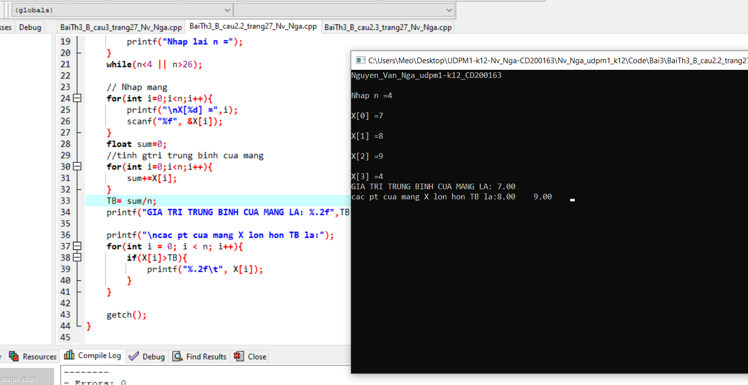

Câu 2.3

Code

/* nhap các so nguye tu ban phim

ket thuc nhap khi du 30 phan tu hoac gtri nhap bang 0

xem co bn so chan vua nhap

hien ra man hinh ket qua

*/

#include<stdio.h>

#include<conio.h>

#include<math.h>

int main(){

puts("Nguyen_Van_Nga_udpm1-k12_CD200163\n");

int X[30], i ;

puts("nhap cac phan tu vao mang X la so nguyen\n");

// nhap mang x

for(i = 0 ;i<30 ;i++){

printf("pt so %d =",i+1);

scanf("%d",&X[i]);

if(X[i] == 0) break;

}

// xem mang co bn phan tu la so chan va hien ra

puts("\ncac pt la so chan:");

for(i = 0; i < 30; i++){

if(X[i] % 2 == 0){

if(X[i] == 0) break;

printf("%d\t", X[i]);

}

}

getch();

}

Ảnh

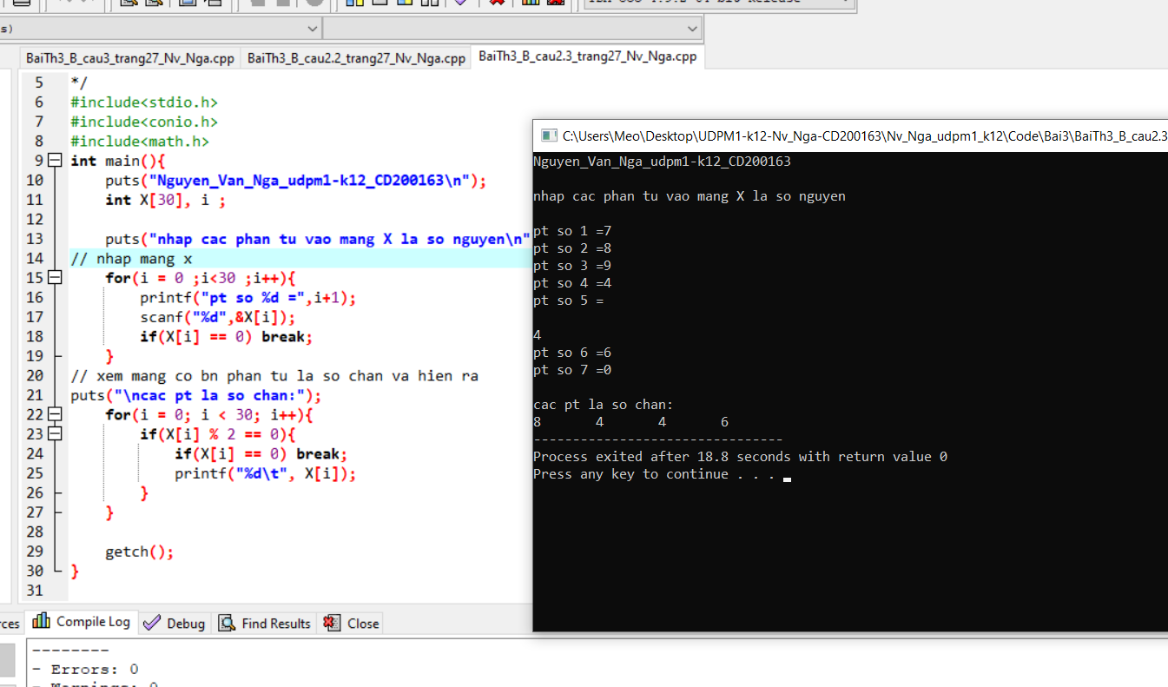

Câu 3

Code

/* - nhap so nguyen n sao cho 6 <= n <= 30

- nhap n so thuc luu vao mang G

- hien lai mang G 8 phan tu tren 1 dong moi phan tuw chiem 6 vi tri voi 2 so le

- tinh gtri TB cua cua mang G

- dem so pt co trong G co gtri lon hown TB va hien ra ma hinh

*/

#include<stdio.h>

#include<conio.h>

#include<math.h>

void nhapmang(int N, float G[]){

for(int i = 0 ; i < N ; i++ ){

printf("\nnhap pt so %d =",i+1);

scanf("%f",&G[i]);

}

}

void hienmang(int N, float G[]){

for(int i = 0 ; i < N ; i++ ){

printf("%6.2f",G[i]);

if((i+1) % 8 ==0){

printf("\n");

}

}

}

float trungbinh(int N, float G[]){

float TB = 0;

for(int i = 0 ; i < N ; i++ ){

TB += G[i];

}

return TB/N;

}

int soptlon(int N, int dem, float G[]){

for(int i = 0 ; i < N ; i++ ){

if(G[i] > trungbinh(N,G))

dem++;

}

return dem;

}

int main(){

puts("Nguyen_Van_Nga_udpm1-k12_CD200163\n");

int N, i, dem=0;

printf("Nhap so N (6-->30) =");

do{

scanf("%d",&N);

if(N < 6 || N >30)

printf("nhap sai roi! nhap lai N=");

}while(N < 6 || N >30);

float G[N];

nhapmang(N,G);

puts("\nmang vua nhap la :");

hienmang(N,G);

printf("\nSo pt lon hon gtri TB = %.2f la: %d",trungbinh(N,G),soptlon(N,dem,G));

getch();

}

Ảnh

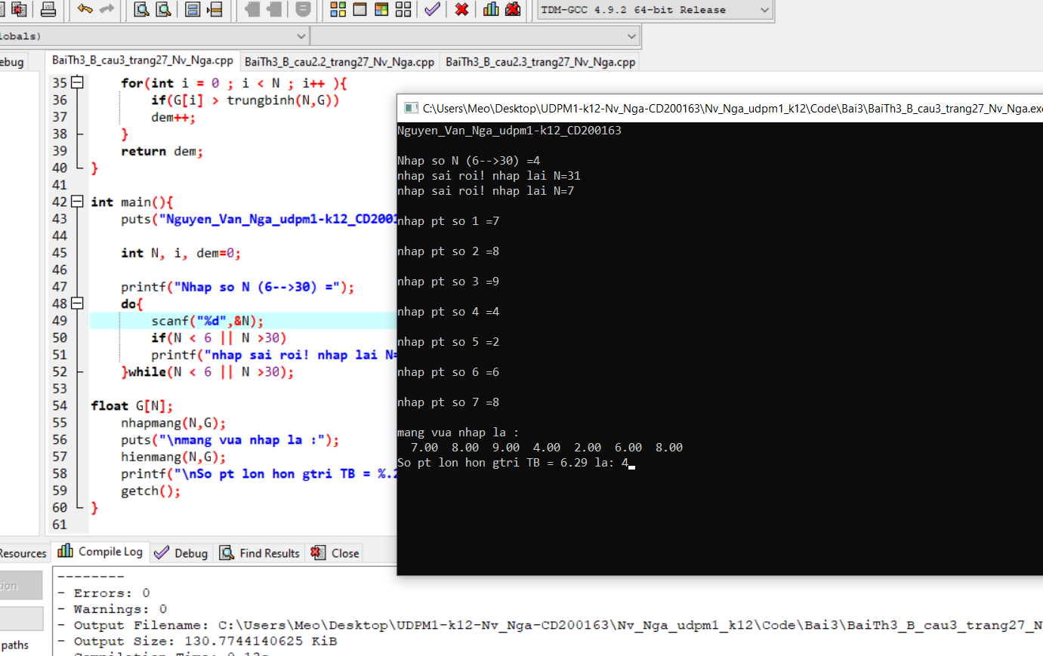

Câu 4;

Code

/*

- nhap 1 so nguyen N sao cho 4 <= N <=30

- nhap N so thhuc luu vao mang T

- Hien mang T 6 phan tu tren 1 dong moi phan tu chiem 5 vitri voi 2 so le

- Tinh tong cacs pt cua mang T co gtri -3 < T[i] <= 6

*/

#include<stdio.h>

#include<conio.h>

#include<math.h>

void nhapmang(int n, float T[]){

for(int i = 0; i < n; i++){

printf("\nnhap pt so %d =", i+1);

scanf("%f",&T[i]);

}

}

void xuatmang(int n, float T[]){

printf("\n Mang vua nhap la:\n");

for(int i = 0; i < n; i++){

printf("%5.2f\t",T[i]);

if((i + 1) % 6 == 0)

printf("\n");

}

}

float tong(int n, float T[]){

float tong = 0;

for(int i = 0; i < n; i++){

if(T[i] > -3 && T[i] < 7)

tong+= T[i];

}

return tong;

}

int main(){

puts("Nguyen_Van_Nga_udpm1-k12_CD200163\n");

int n;

printf("Nhap n trong khoang (4 --> 30)=");

do{

scanf("%d",&n);

if(n < 4 || n > 30)

printf("sai roi ! nhap lai :");

}while(n < 4 || n > 30);

float T[n];

nhapmang(n,T);

xuatmang(n,T);

printf("\nTong cac pt cua mang T[%d] co gtri tu -3 < T[i] <= 6 la : %.2f", n, tong(n,T));

getch();

}

Ảnh

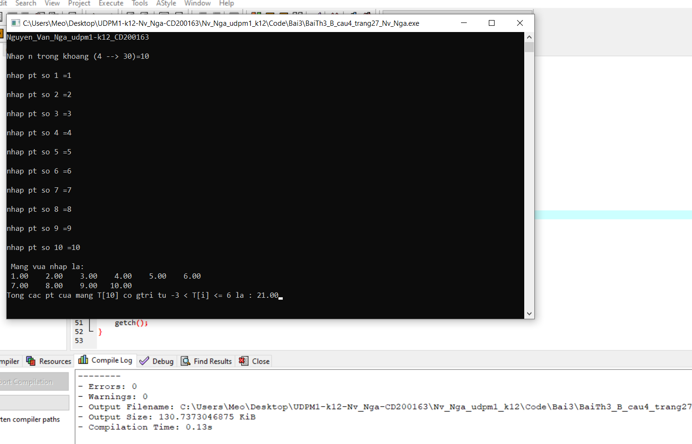

Bài thực hành số 4

Câu 2;

Code

/*

- nhap mot xau ky tu co do dai koo qua 40 yeu cau kiem tra do dai xau

- chuyen xau vua nhap ve chu hoa va hien lai

- hien l?i xau theo thu tu nguoc lai

*/

#include<stdio.h>

#include<conio.h>

#include<math.h>

#include<string.h>

int main(){

puts("Nguyen_Van_Nga_udpm1-k12_CD200163\n");

char xau[40];

printf("nhap chuoi cac ky tu:");

do{

gets(xau);

if(strlen(xau)>40)

printf("xau dai qua nhap lai! =");

else if(strlen(xau)<=0)

printf("xau ngan qua nhap lai ! =");

}while( strlen(xau)>40 || strlen(xau) <= 0 );

printf("xau vua nhap la: %s",xau);

printf("\nchuyen xau ve chu hoa : %s",strupr(xau));

printf("\ndao nguoc xau : %s",strrev(xau));

getch();

}

Ảnh

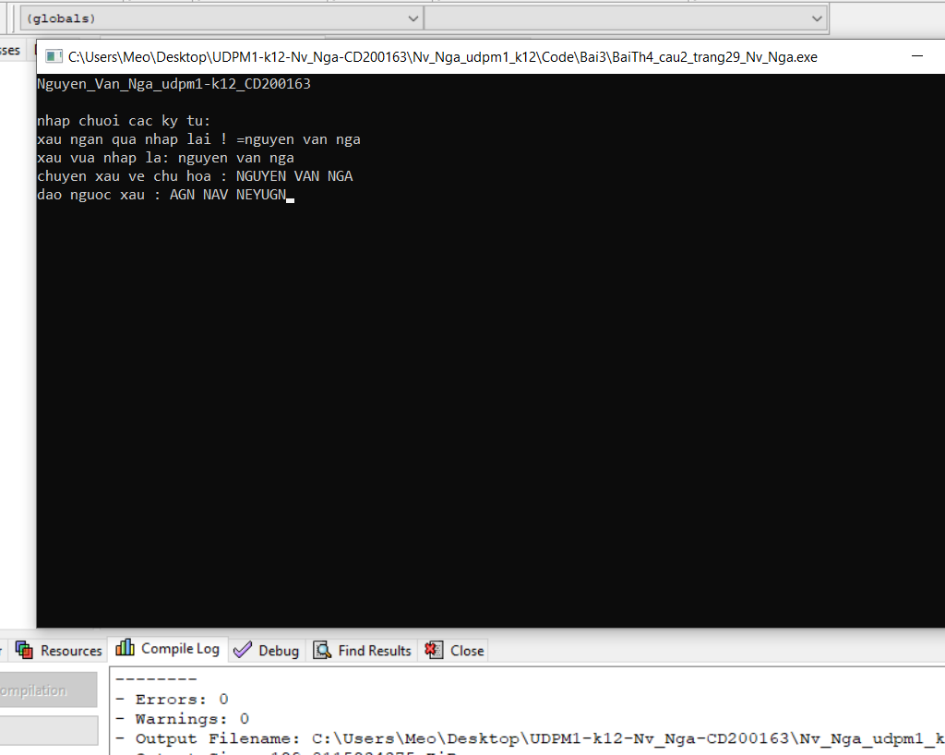

Bài thực hành số 5

Câu 2;

Code

/*

-

*/

#include<stdio.h>

#include<conio.h>

#include<math.h>

#include<string.h>

int main(){

puts("Nguyen_Van_Nga_udpm1-k12_CD200163\n");

int n;

printf("Nhap n= ");

do{

scanf("%d",&n);

if(n < 3 || n > 30)

printf("Sai roi! Nhap lai n =");

}while(n < 3 || n > 30);

struct sinh_vien{

char ma_sv[10];

char ho_ten[25];

float diem;

};

struct sinh_vien sv[n];

for(int i = 0; i < n; i++ ){

float diem_thi;

char str[25];

printf("Nhap thong tin sv thu %d\n",i+1);

printf("\nMa sv:"); fflush(stdin);

gets(str); strcpy(sv[i].ma_sv,str);

printf("Ho va ten:"); fflush(stdin);

gets(str); strcpy(sv[i].ho_ten,str);

printf("Diem thi:");

scanf("%f",&diem_thi);

sv[i].diem=diem_thi;

}

puts("THONG TIN VE CAC SV");

printf("\n%-5s%-10s%-25s %-10s","STT", "MSSV", "Ho Ten", "Diem");

for(int i = 0; i < n; i++ ){

printf("\n%-5d%-10s%-25s %-3.1f",i+1,sv[i].ma_sv, sv[i].ho_ten, sv[i].diem);

}

getch();

}

ảnh

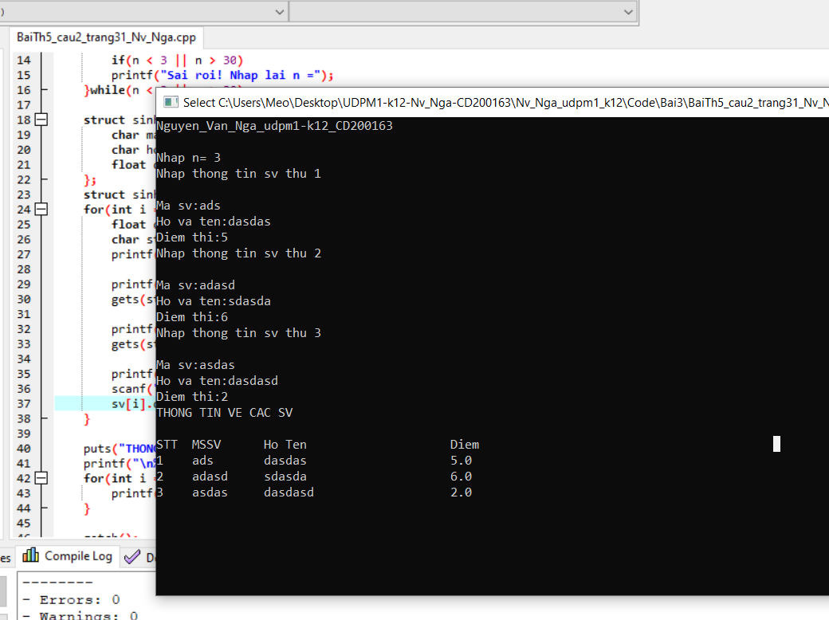

Câu 3.1

Code

/*

- Nhap 1 so nguyen duong n thoa man dk 5<= n <=20

- nhap thong tin cua n sinh vien moi sv gom cac tt sau

+ ho va ten(ko qua 30 ky tu)

+ diem thi mon thhu nhat

+ diem thi mon thu 2

*/

#include<stdio.h>

#include<conio.h>

#include<math.h>

#include<string.h>

int main(){

puts("Nguyen_Van_Nga_udpm1-k12_CD200163\n");

int n;

printf("Nhap n= ");

do{

scanf("%d",&n);

if(n < 5 || n > 20)

printf("Sai roi! Nhap lai n =");

}while(n < 5 || n > 20);

struct sinh_vien{

char ho_ten[25];

float diem1,diem2;

};

struct sinh_vien sv[n];

for(int i = 0; i < n; i++ ){

float diem_thi1, diem_thi2;

char str[25];

printf("Nhap thong tin sv thu %d\n",i+1);

printf("Ho va ten:"); fflush(stdin);

gets(str); strcpy(sv[i].ho_ten,str);

printf("Diem thi:");

scanf("%f",&diem_thi1);

sv[i].diem1=diem_thi1;

printf("Diem thi:");

scanf("%f",&diem_thi2);

sv[i].diem2 =diem_thi2;

}

puts("THONG TIN VE CAC SV");

printf("\n%-5s%-25s %-10s %-10s","STT", "Ho Ten", "Diem 1", "Diem 2");

for(int i = 0; i < n; i++ ){

printf("\n%-5d%-25s %-10.1f %-3.1f",i+1, sv[i].ho_ten, sv[i].diem1, sv[i].diem2);

}

getch();

}

Ảnh

